Why do so many HS history teachers lecture so much?
24FridayApr 2015

Posted by grantwiggins in General
≈ 117 Comments
Really, why do HS teachers lecture so much? Almost every HS I go to I see teachers talking and kids listening (or not) more in History than any other course.
And you needn’t take my anecdotal word for it. For the past year, students taking our survey have been asked to respond to questions about use of time in class. Here are the results for HS students (the “skipped” vs “answered” number refers to prior years when the question was not asked; this reflects all HS students from this school year, with no filtering out of answers):
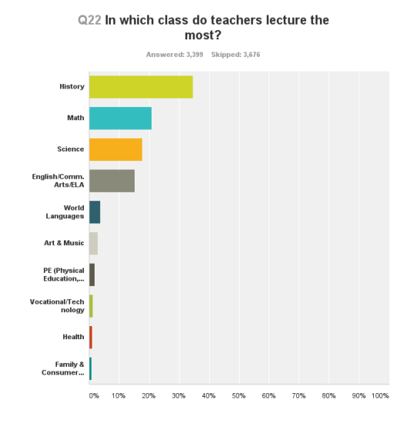
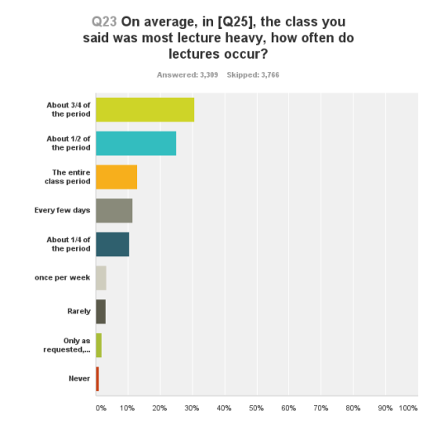
So, half of HS teachers lecture at least 3/4 of the period regularly – some all period.
My question is basic, history teachers. Given that most history textbooks are comprehensive and reasonably well-written, why do you feel the need to talk so much? Your colleagues in science and English, for example, do not feel the same urge.
And PLEASE don’t tell me there is ‘so much to cover’ – that is silly. You are paid to cause understanding, not on how many words you speak. And don’t tell me you can’t do projects and simulations. My old friend and former colleague Mark Williams has prepared kids for AP for decades by doing cool simulations and performance challenges (e.g. Silk Road trading game plus debrief, editorial team decision on how to eulogize Sam Colt, etc.). The best teacher I have ever seen at the HS level, Leon Berkowitz at Portland HS years ago, organized his entire history course using the Steve Allen Meeting of Minds format.
Furthermore, most history programs have mission/goal statements that identify skills, performance abilities, and critical thinking that should be highlighted. (And the new AP framework which also does so is based on UbD.) That requires coaching kids to do things.
I can only see two good reasons for lecturing at length, sometimes, in history:
1. You have done original research that isn’t written down in a book
2. You have rich and interesting knowledge based on research that can overcome confusions and missing elements in the current course.
I am NOT saying “Don’t Lecture.” I am wondering why you do it so much, more than I think reasonably is necessary to achieve your goals. (You might want to read the research on lectures while you’re at it, especially the forgetting and disengagement that comes after 20 minutes for college learners, never mind HS kids).
What am I missing? Or: what might you do differently for 3/4 of the period, to engage and equip students? I think any reasonable job description of “teacher” demands that you rethink this habit.
PS: A number of tweets and a few comments below cite the reason as: “Kids can’t/won’t read the text.” But then that is a more serious problem than you lecturing all the time: they will be utterly unprepared for college at any level. Why isn’t this treated as a departmental priority? Why aren’t you looking for better books? Why aren’y you proving them with better incentives to read (e.g. necessary for simulations, debates, and Seminars)?

